|  |  |  |
| --- | --- | --- |
| **Competitor Name** | **:** |  |
|  |  |  |
| **Work Station No** | **:** |  |



# WORLD SKILLS SINGAPORE 2020

**INFORMATION TECHNOLOGY SOFTWARE SOLUTIONS FOR BUSINESS**

**Style Guide**

## 1 - 3 Oct 2020

**INSTRUCTIONS**

**Updated as at 20 March 2020**

# The Logo

The logo has been designed with two main colours in mind. Clearance, minimum size, cases for misuse and variations will be shown in this section. The basic rules of usage are as follows:

# Exclusion Zone

To protect the clarity and integrity of the logo, it has an exclusion zone which is a clearance or area of clear space around it. As marked below by grey boxes, the proposed area is 15% of height and width from each side. This improves clarity, retains identity and ensures consistency.

## 

# Image result for worldskills asean 2020 png"Variations

The following variations of the logo are provided. Competitors can resize as appropriate, maintaining the size ratio and exclusion. The monochrome is also provided in both white (to be used on dark backgrounds) and black (to be used in light backgrounds). All the images are transparent where applicable.

# Misuse

|  |  |
| --- | --- |
| **Stretch:**  You must not stretch, skew or rotate the logo for use in your work |  |
|  |  |
| **Colour**:  You may not change the colour palette, hue, or  saturation used in the logo to match your work |  |
|  |  |
| **Background**:  Never place the logo over a photo, textures, or coloured background where there will not be sufficient amount of  contrast to make it legible | Image result for worldskills asean 2020 png" |
|  |  |
| **Remastering**:  You may not re-create the logo in any form or shape either by removing or moving around components  of the logo |  |

# Colour Palette

The following are the recommended colour palettes to be used in the applications.

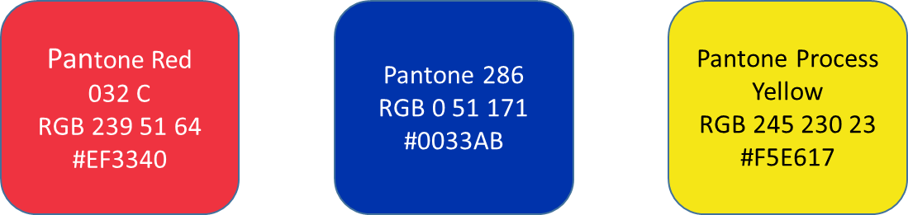

# Fonts

Here are the recommendations of fonts to be used in designing user interfaces for all applications. We will provide details of a secondary font as well only to be used where the primary font is not available.

# PRIMARY FONT

**Helvetica Normal**

|  |  |  |  |  |  |  |  |  |  |  |  |  |
| --- | --- | --- | --- | --- | --- | --- | --- | --- | --- | --- | --- | --- |
| a | b | c | d | e | f | g | h | i | j | K | l | m |
| n | o | p | q | r | s | t | u | v | w | X | y | z |
| A | B | C | D | E | F | G | H | I | J | K | L | M |
| N | O | P | Q | R | S | T | U | V | W | X | Y | Z |

**Helvetica Bold**

|  |  |  |  |  |  |  |  |  |  |  |  |  |
| --- | --- | --- | --- | --- | --- | --- | --- | --- | --- | --- | --- | --- |
| **a** | **b** | **c** | **d** | **e** | **f** | **g** | **h** | **i** | **j** | **K** | **l** | **m** |
| **n** | **o** | **p** | **q** | **r** | **s** | **t** | **u** | **v** | **w** | **X** | **y** | **z** |
| **A** | **B** | **C** | **D** | **E** | **F** | **G** | **H** | **I** | **J** | **K** | **L** | **M** |
| **N** | **O** | **P** | **Q** | **R** | **S** | **T** | **U** | **V** | **W** | **X** | **Y** | **Z** |

# TITLE FONT

**Myriad Pro**

|  |  |  |  |  |  |  |  |  |  |  |  |  |
| --- | --- | --- | --- | --- | --- | --- | --- | --- | --- | --- | --- | --- |
|  |  |  |  |  |  |  |  |  |  |  |  |  |
|  |  |  |  |  |  |  |  |  |  |  |  |  |
|  |  |  |  |  |  |  |  |  |  |  |  |  |
|  |  |  |  |  |  |  |  |  |  |  |  |  |

**Myriad Pro Bold**

|  |  |  |  |  |  |  |  |  |  |  |  |  |
| --- | --- | --- | --- | --- | --- | --- | --- | --- | --- | --- | --- | --- |
|  |  |  |  |  |  |  |  |  |  |  |  |  |
|  |  |  |  |  |  |  |  |  |  |  |  |  |
|  |  |  |  |  |  |  |  |  |  |  |  |  |
|  |  |  |  |  |  |  |  |  |  |  |  |  |

# SECONDARY FONT

**Verdana Regular (Verdana)**

|  |  |  |  |  |  |  |  |  |  |  |  |  |
| --- | --- | --- | --- | --- | --- | --- | --- | --- | --- | --- | --- | --- |
| a | b | c | d | e | f | g | h | i | j | K | l | m |
| n | o | p | q | r | s | t | u | v | w | X | y | z |
| A | B | C | D | E | F | G | H | I | J | K | L | M |
| N | O | P | Q | R | S | T | U | V | W | X | Y | Z |

**Verdana Bold (Verdana Bold)**

|  |  |  |  |  |  |  |  |  |  |  |  |  |
| --- | --- | --- | --- | --- | --- | --- | --- | --- | --- | --- | --- | --- |
| **a** | **b** | **c** | **d** | **e** | **f** | **g** | **h** | **i** | **j** | **K** | **l** | **m** |
| **n** | **o** | **p** | **q** | **r** | **s** | **t** | **u** | **v** | **w** | **X** | **y** | **z** |
| **A** | **B** | **C** | **D** | **E** | **F** | **G** | **H** | **I** | **J** | **K** | **L** | **M** |
| **N** | **O** | **P** | **Q** | **R** | **S** | **T** | **U** | **V** | **W** | **X** | **Y** | **Z** |